Lab1 Exploring the AWS Shared Responsibility Model
Task 1

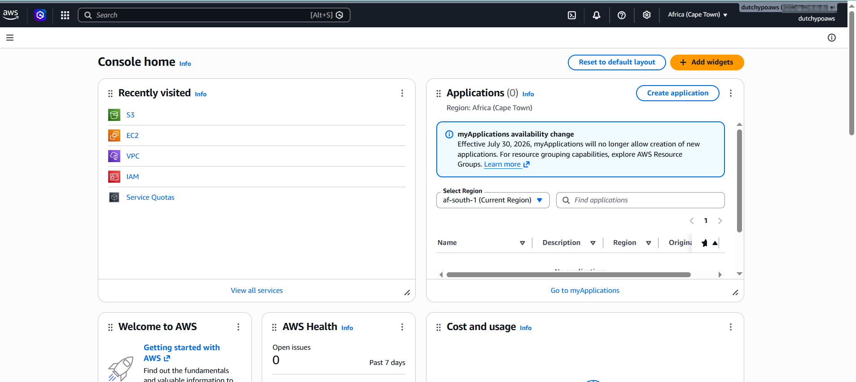

Task 2
- Amazon EC2
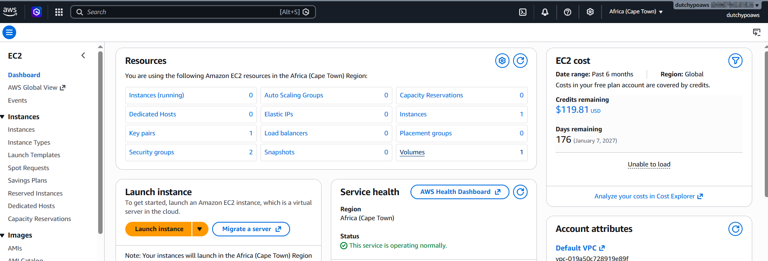

- Amazon S3

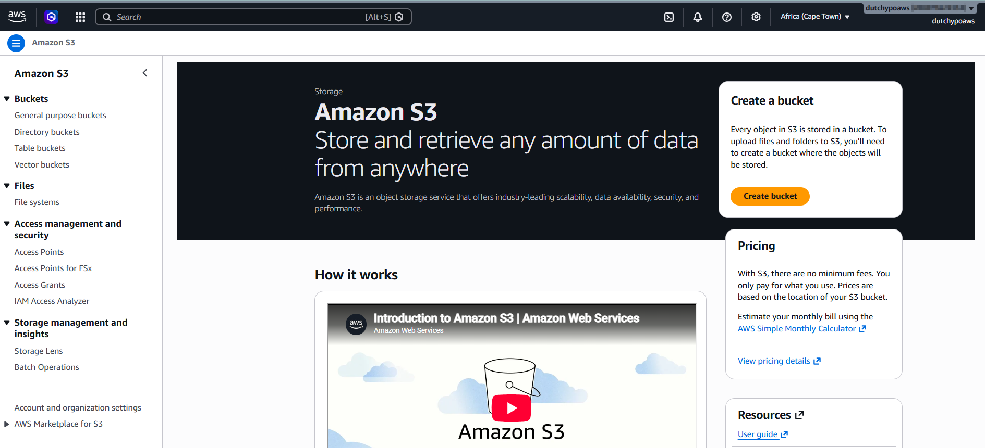

- Amazon RDS

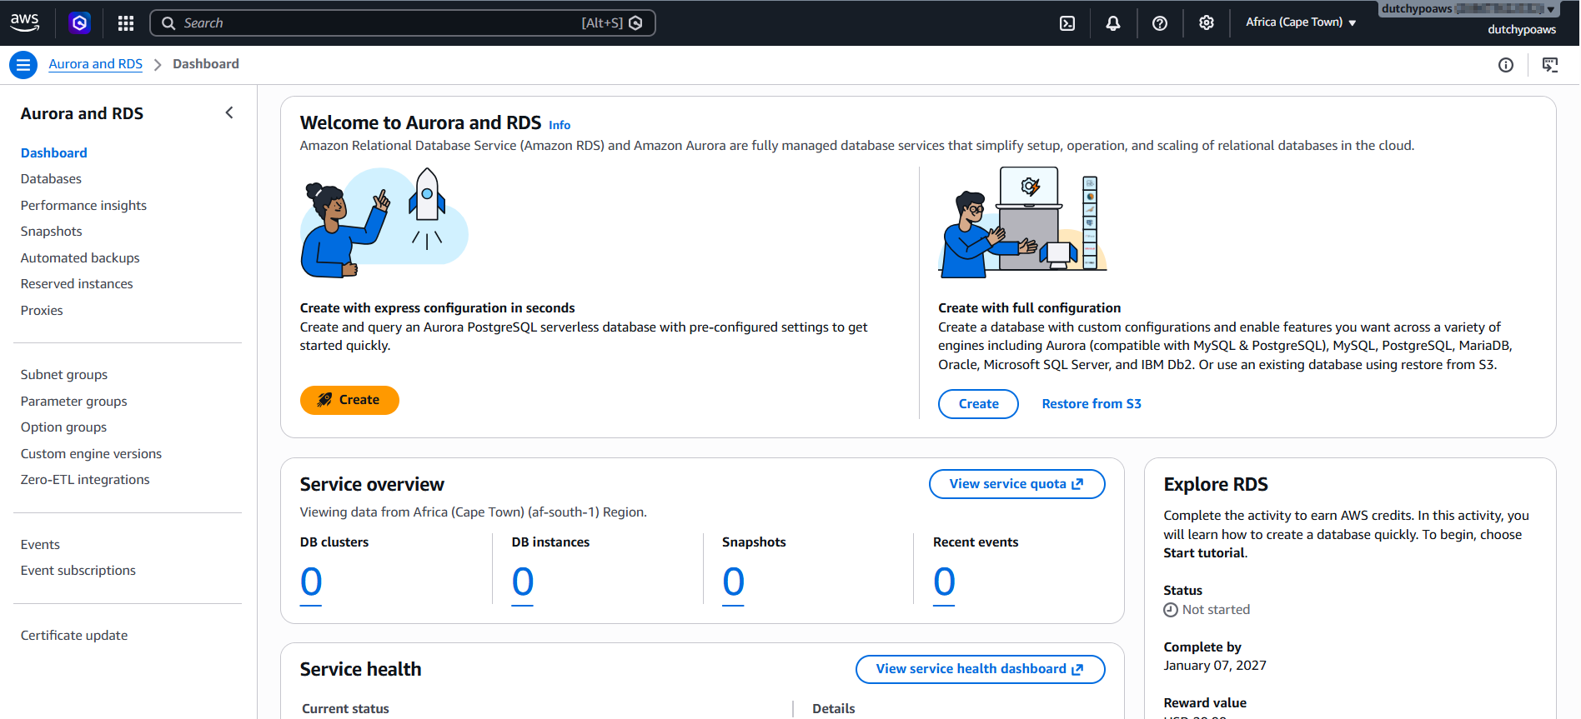

- AWS Lambda
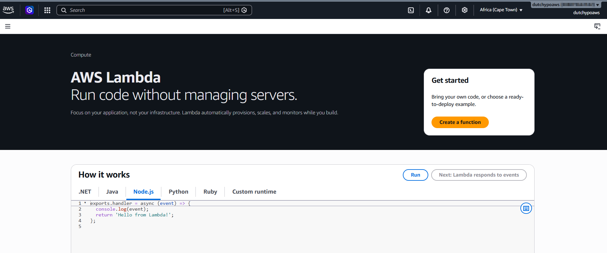

Task 3
RESPONSIBILITY | AWS | CUSTOMER
Data Centers
Customer Data
IAM Users
Physical Servers
Bucket Policies
Security Groups
Operating System
Application Code

